Lab Report

Your Information
Your Name:
Assignment Title:

Screenshots
- Establish a relationship between Orders and Returns.

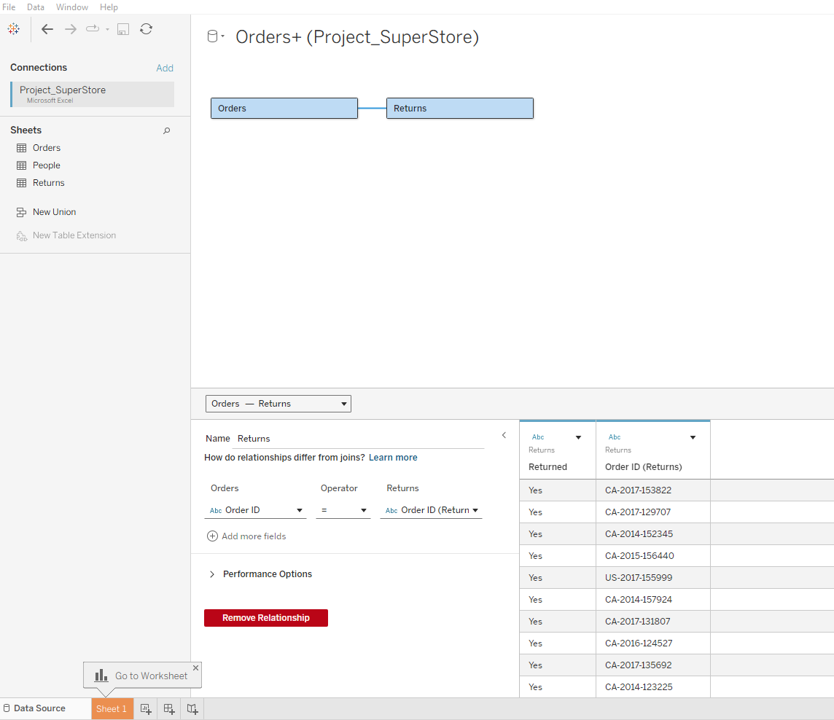
- Create a sheet called Profit Ratio by Geography. Create a calculated field called Profit Ratio in this sheet, which is the sum(Profit)/sum(Sales). Create a map visualization that shows the Profit Ratio by State. Allow the user to filter by Region.
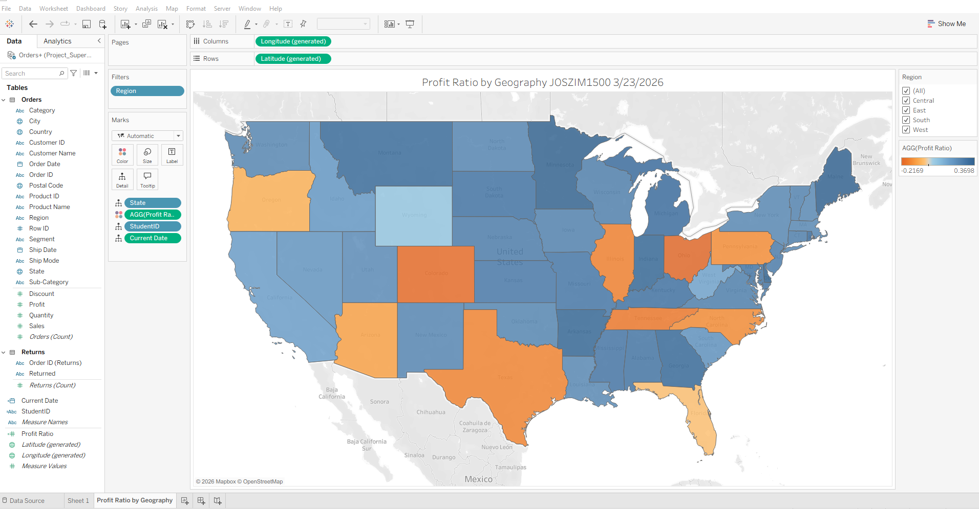
- Create a sheet called Sales by Category. In this sheet, create an area chart of Monthly Sales by Category.
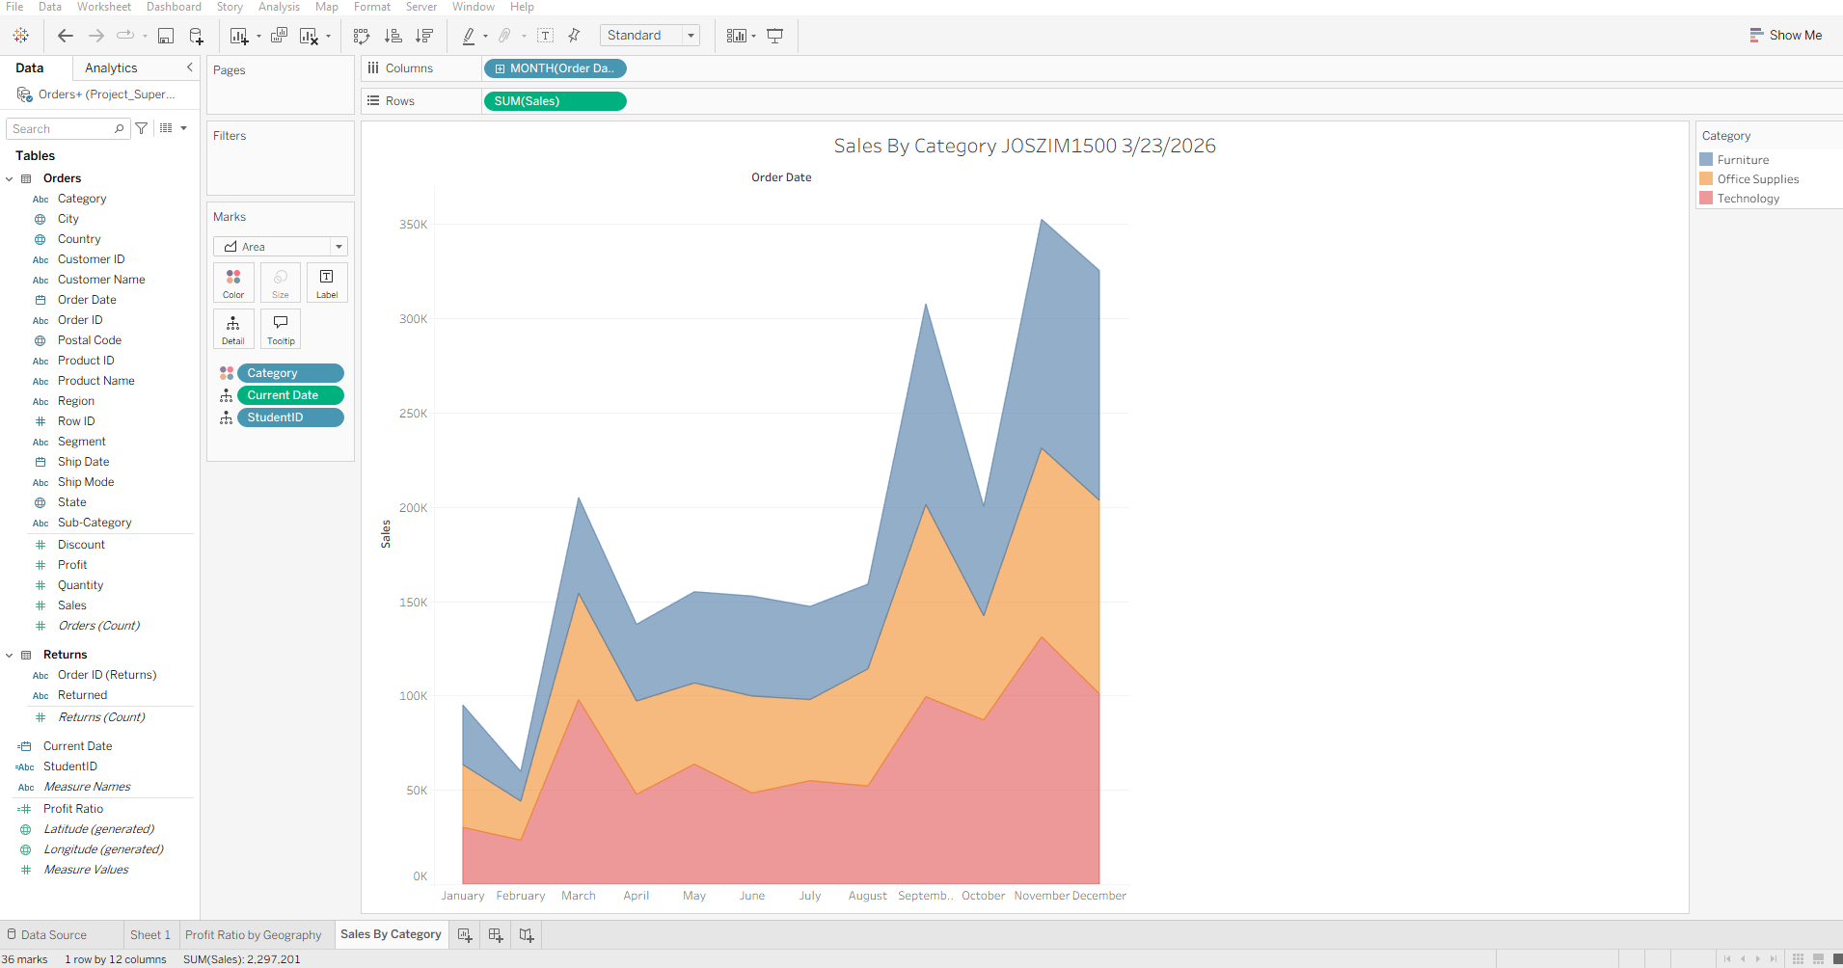

- Create a sheet called Sales by Segment. In this sheet, create an area chart of Monthly Sales by Segment.
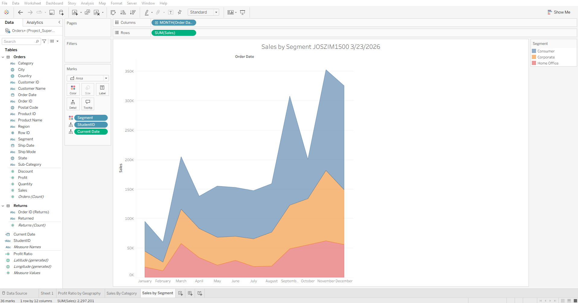
- Create a sheet called Profit Ratio by City. Create a bar chart that shows Profit Ratio by City.
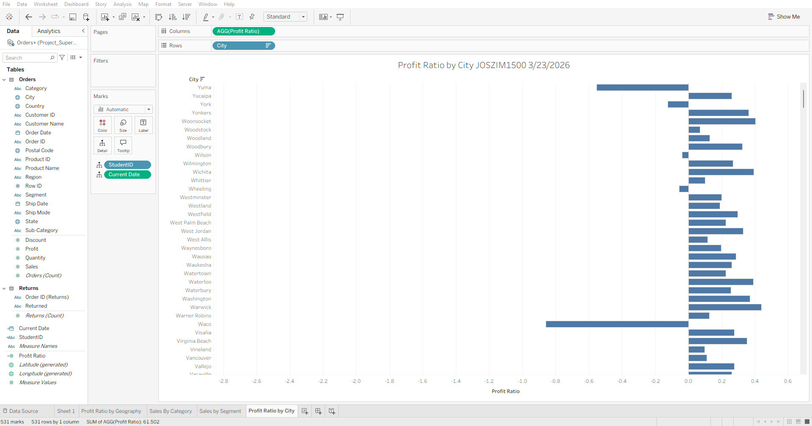

- Change the tooltip of the Profit Ratio by State map you created in Step 2 to use the Profit Ratio by City bar chart. (Hint: Under the Marks Card of the map, click on Tooltip, and Insert the "Profit Ratio by City" sheet.)
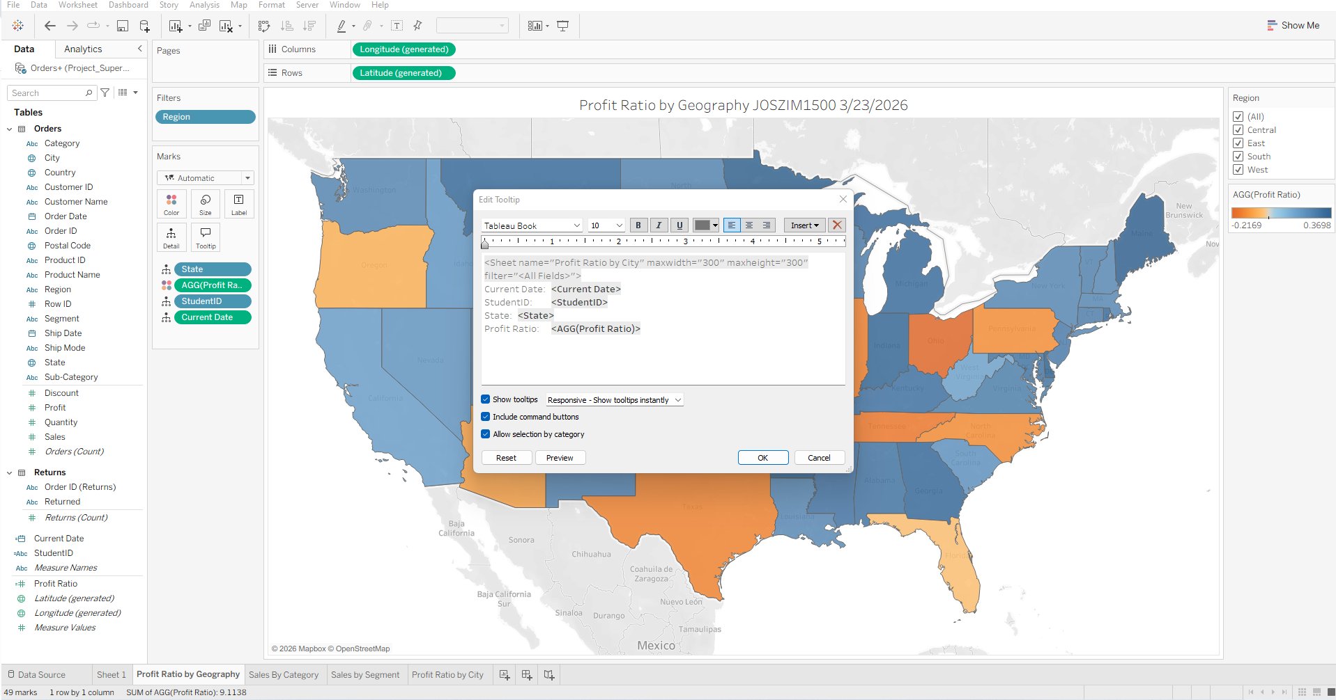
- Create a dashboard called Executive Overview that shows the sheets created in Steps 2-4 above in a visually appealing format. Put the Map sheet on top and the sales sheets side-by-side below it. Ensure that the map filter filters all the sheets on your dashboard.
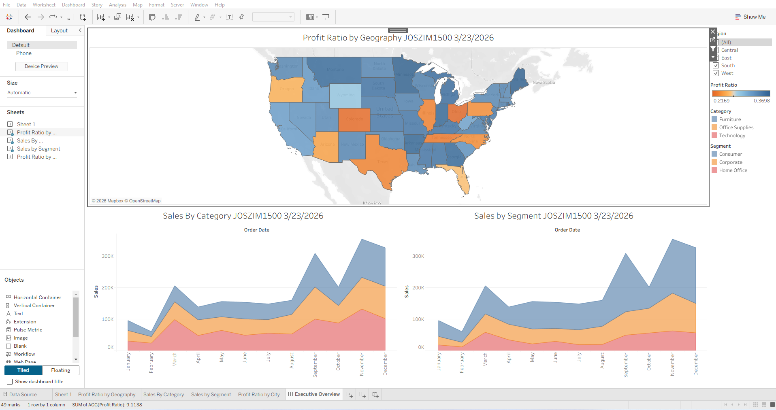

Questions
- What are the top two (2) most profitable states?
Minnesota at .3624 and Maine at .3577
- What are the bottom two (2) least profitable states?
Colorado at -.2033 and Ohio at -.2169

